**CHAPTER 5**

**SYSTEM DESIGN**

“Design is simulating what we want to make or do before we make or do it as many times as may be necessary to feel confident in final results.”

Design is a derivation of art and science. Software design sits at the technical kernel of software engineering process and is applied regardless of the software process model that is used. System design is the most important phase of the proposed system. This phase is time consuming part of project. Without design we risk building a unstable system; one that will fail when small changes are made; one that may be difficult to test. Designing is done keeping in mind the demands and requirements of organization. With the objective of reducing the problem faced the existing system to the greatest extent. This chapter deals with designing of the system which comprises the following design considerations.

* Software Design
* Database Design

Design serves as the foundation in software development. Without design, we risk building an unstable system; one that will fail when small changes are made; one which will be difficult to test and whose quality cannot be accessed until late in the system development. The initial primary goal of the system design is to ensure that the structure of the system supports the right function and organizes them to let user work efficiently. A badly design system will result in high level of user errors. At worst it will cause the system to be discarded, irrespective of its functionality. The design of the project should be user friendly. The names used in database should be simple. In the database design, the database tables and fields are developed after careful consideration of existing system to avoid repetition and errors. System displays error message when user enters wrong data in different fields. By visual modeling anyone can easily understand the flow of the system and users of system.

**5.1) Software Design**

Software design is the important phase of the system design. This part shows how the system will work and describe the structure of the software; software structure determines how the system will provide the design function to the user.

Software design can be visualized through Visual Modeling using UML.

**5.1.1) Visual Modeling**

“Visual Modeling is the process of taking information from the model and displaying it graphical elements. A standard is vital to realizing one of the benefits of visual modeling i.e, communication. Communication between users, developers, analysts, testers, managers and anyone else involved with a project is a primary purpose of visual modeling.”

UML is a standard that has been adopted by majority of the industry as well as the standards governing boards such as ANSI and The Object Management Group (OMG). UML allows people to develop several different types of visual diagrams that represent various aspects of the system. Rational Rose supports the development of the majority of these models, as follows:

* Use Case Diagram
* Sequence Diagram
* Collaboration Diagram
* Relationship Diagram

**5.1.1.1) Use Case Diagram**

Use case diagrams show the interaction between use cases, which represents system functionality, and actors, which represents the people or systems that provide or receive information from the system. Use cases represent the requirements of the system from user’s perspective. So, use cases are the functionality that the system provides. Actors are the administrator and the user of the system.

**Figure 5.1 Use Case Diagram (Administrator)**

**Figure 5.1 Use Case Diagram (Registration User)**

**Use Case Diagram For Registered User To Add Workspace**

**Use Case For User Log In**

**User Diagram To Update Posts**

**5.1.1.2) Use Case Description**

The user case description defines that what happens when the use cases performed. It corresponds to a sequence of transactions performed by the system, which yields measurable results of value to a particular actor. Use case is a narrative documentation that describes the sequence of events of an actor.

Main use cases in my system are:

|  |  |
| --- | --- |
| Name: | Delete User |
| Actor | Administrator. |
| Goal in Context | To delete a user from system. |
| Pre-Conditions | Actor must be administrator. |
| Post-Conditions | The system must delete the user form database. |
| Normal Flow | Administrator logs in and clicks the delete button against the particular user. |
| Alternate Flow | The system prompts the administrator for wrong inputs and invalid data entry. |

**Table 5.1 Delete User Use Case**

|  |  |
| --- | --- |
| Name: | Delete Workspace |
| Actor | Administrator. |
| Goal in Context | To delete workspace of a user. |
| Pre-Conditions | Actor must be administrator. |
| Post-Conditions | The system must delete the workspace form database. |
| Normal Flow | Administrator logs in and clicks the details button and then clicks the delete workspace button. |
| Alternate Flow | The system prompts the administrator for wrong inputs and invalid data entry. |

**Table 5.2 Delete Workspace of User**

|  |  |
| --- | --- |
| Name: | Send Message |
| Actor | Administrator or User |
| Goal in Context | To send message to all users and Admins. |
| Pre-Conditions | Actor must be administrator and user. |
| Post-Conditions | The system must sends the message to all users and administrator. |
| Normal Flow | Administrator or user logs in and writes their messages on a text box and presses enter. |
| Alternate Flow | The system prompts the administrator or user for wrong inputs and invalid data entry. |

**Table 5.3 Send Message Use Case**

|  |  |
| --- | --- |
| Name: | Suspend User. |
| Actor | Administrator. |
| Goal in Context | To block a user. |
| Pre-Conditions | Actor must be administrator. |
| Post-Conditions | The system must blocks a user from login in. |
| Normal Flow | Administrator logs in and clicks the suspend link against the particular user. |
| Alternate Flow | The system prompts the administrator or user for wrong inputs and invalid data entry. |

**Table 5.4 Suspend User Use Case**

|  |  |
| --- | --- |
| Name: | Search User. |
| Actor | Administrator. |
| Goal in Context | To search any user. |
| Pre-Conditions | Actor must be administrator. |
| Post-Conditions | The system must give the list of searched users. |
| Normal Flow | Administrator logs in and types the starting characters of user name to be searched and the list of users with related names with be displayed. |
| Alternate Flow | The system prompts the administrator or user for wrong inputs and invalid data entry. |

|  |  |
| --- | --- |
| Name: | Print User List. |
| Actor | Administrator. |
| Goal in Context | To print out the list of all users. |
| Pre-Conditions | Actor must be administrator. |
| Post-Conditions | The system must open up the print option to print page. |
| Normal Flow | Administrator logs in and clicks on the print button to get the print of the users. |
| Alternate Flow | The system prompts the administrator or user for wrong inputs and invalid data entry. |

**Table 5.5 Search User Use Case**

**Table 5.6 Print User Use Case**

|  |  |
| --- | --- |
| Name: | View All Posts. |
| Actor | Administrator. |
| Goal in Context | To view all the posts of all users. |
| Pre-Conditions | Actor must be administrator. |
| Post-Conditions | The system must give the list of all the posts against all the users. |
| Normal Flow | Administrator logs in and clicks on the Post link on the menu bar and then the list of all posts are viewed. |
| Alternate Flow | The system prompts the administrator or user for wrong inputs and invalid data entry. |

|  |  |
| --- | --- |
| Name: | Delete Post. |
| Actor | Administrator. |
| Goal in Context | To delete the selected post of any user. |
| Pre-Conditions | Actor must be administrator. |
| Post-Conditions | The system must delete the selected post from the database. |
| Normal Flow | Administrator logs in and clicks the post link on the menu bar, which opens the page viewing all the posts then the administrator clicks on the delete button to delete particular post. |
| Alternate Flow | The system prompts the administrator or user for wrong inputs and invalid data entry. |

**Table 5.7 View Posts Use Case**

**Table 5.8 Delete Post Use Case**

|  |  |
| --- | --- |
| Name: | Print Posts. |
| Actor | Administrator. |
| Goal in Context | To print all the posts of all users. |
| Pre-Conditions | Actor must be administrator. |
| Post-Conditions | The system must print the page. |
| Normal Flow | Administrator logs in and clicks the post link on the menu bar, and then clicks on the print button. |
| Alternate Flow | The system prompts the administrator or user for wrong inputs and invalid data entry. |

**Table 5.9 Print Post Use Case**

|  |  |
| --- | --- |
| Name: | View Workspaces. |
| Actor | Administrator. |
| Goal in Context | To view all the workspaces against all users. |
| Pre-Conditions | Actor must be administrator. |
| Post-Conditions | The system must give the list of all the workspaces. |
| Normal Flow | Administrator logs in and clicks the workspaces tab on the menu bar and the list of all workspaces of users are displayed. |
| Alternate Flow | The system prompts the administrator or user for wrong inputs and invalid data entry. |

**Table 5.10 View Workspaces Use Case**

|  |  |
| --- | --- |
| Name: | Delete Workspace. |
| Actor | Administrator. |
| Goal in Context | To Delete all . |
| Pre-Conditions | Actor must be administrator. |
| Post-Conditions | The system must delete the selected workspaces. |
| Normal Flow | Administrator logs in and clicks the workspaces tab on the menu bar and then clicks the the delete button on of the particular user. |
| Alternate Flow | The system prompts the administrator or user for wrong inputs and invalid data entry. |

**Table 5.11 Delete Workspaces Use Case**

|  |  |
| --- | --- |
| Name: | Contact Admin. |
| Actor | User. |
| Goal in Context | To contact admin. |
| Pre-Conditions | Actor must be user. |
| Post-Conditions | The user must be able to send email to the admin. |
| Normal Flow | The user can send mail to admin even before logging in and also by clicking on the contact us tab on the menu bar. |
| Alternate Flow | The system prompts the administrator or user for wrong inputs and invalid data entry. |

**Table 5.12 Contact Admin Use Case**

**5.1.1.3) Sequence Diagrams**

“Sequence diagrams in UML indicate how events cause transitions from object to object”. They are user to show the flow of functionality through a use case. Actors and objects are shown at the top of the diagram. Each row represents a message passed between actor and objects to perform needed functionality. It depicts the objects and classes involved in the scenario and the sequence of messages exchanged between the objects needed to carry out functionality of scenario.

The following pages are shown from important diagrams about the system.

**Sequence Diagram To Update Post**

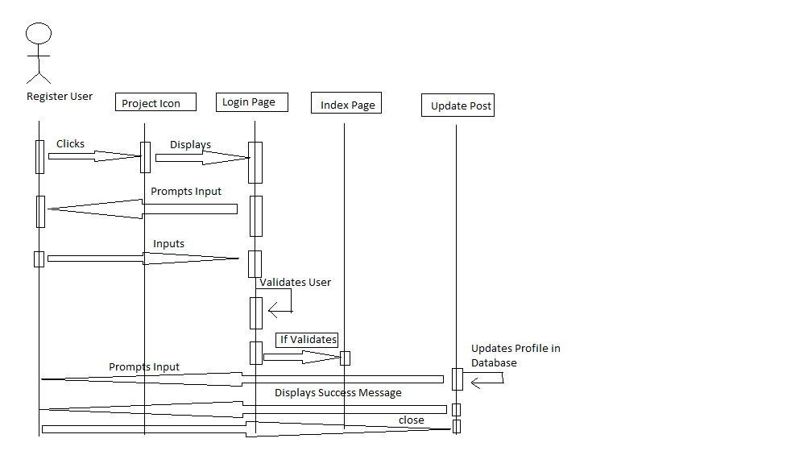

**Collaboration Diagram for Update Post**

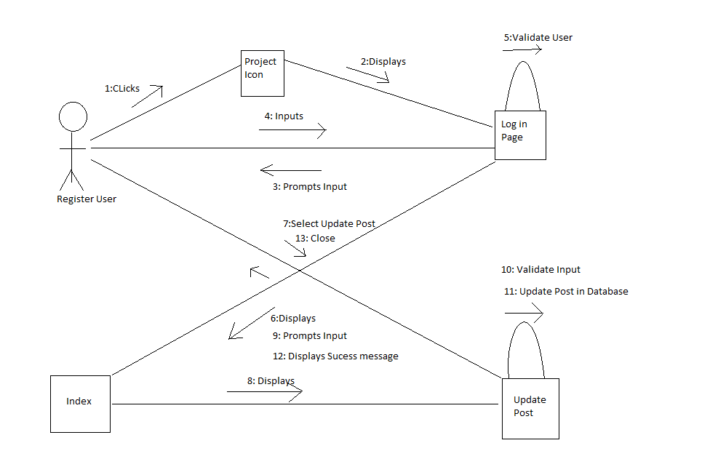

**Collaboration Diagram To Delete User**

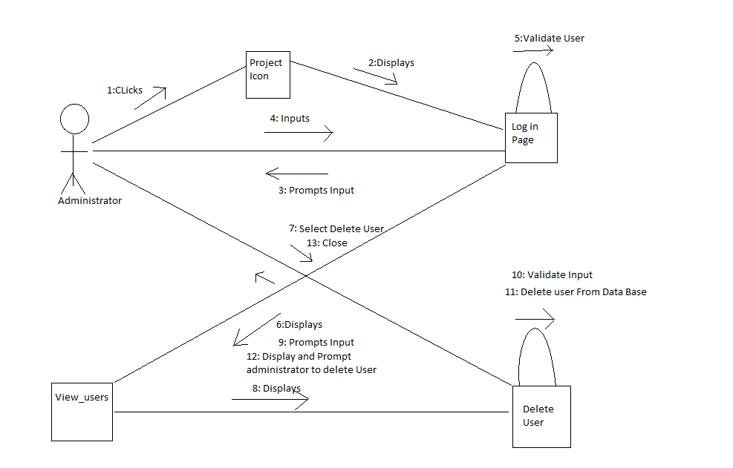

**Collaboration Diagram for Add Workspaces**

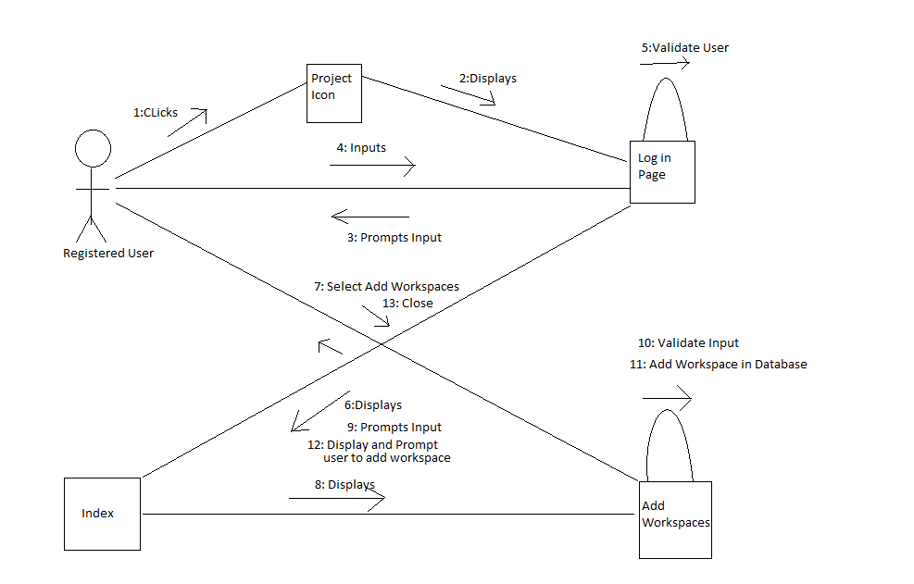

**Collaboration Diagram To Delete Workspaces**

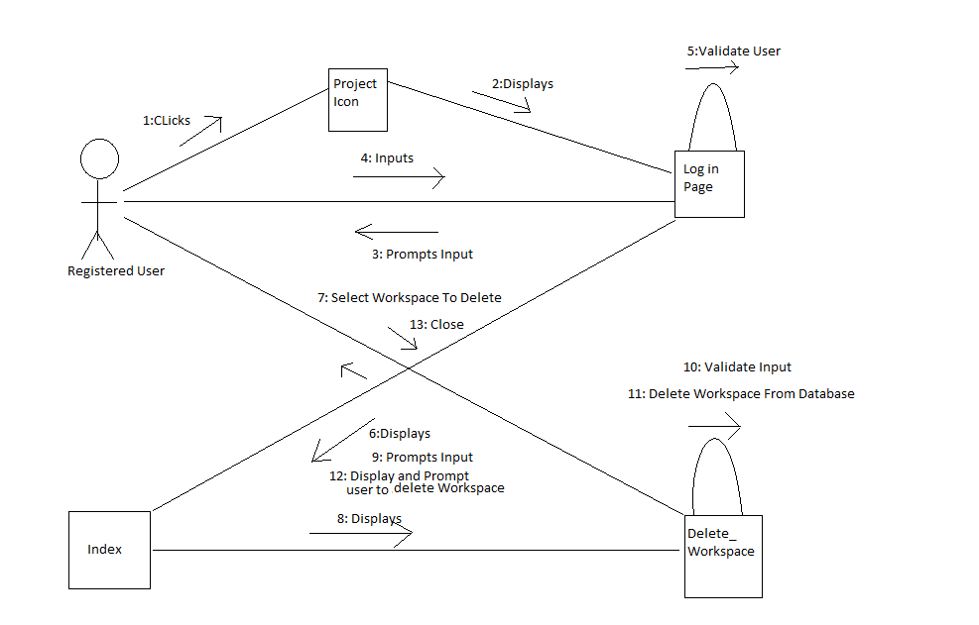

**Sequence Diagram to View Post**

